**Stack and queue**

1. Convert the following infix notation to pretfix notation and explain your process.  
    a/b-c+d*e-a*c
2. Convert the following infix notation to postfix notation and explain your process.

(a/(c*(b+d)))/(e-a)*c

1. Please use stack to convert the following infix notation to postfix notation and show the state of stack step-by-step. Please also describe your algorithm.

a+b*d+c/d

1. Please use a stack to convert the following infix notation to prefix notation and show the state of stack step-by-step. Please also describe your algorithm.

a+b*d+c/d

1. What’s is the issue if a queue has finite capacity? Consider the following case if the capacity is only two.

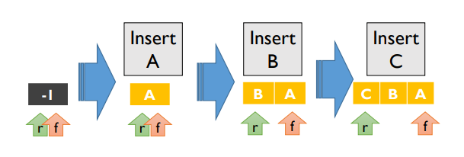

1. The characteristic of the queue is first in first out. There is a way to implement a queue using two stacks. Suppose that you have one queue “A” and two stacks “B” and ”C”. Please use the push and pop functions of the stack to implement the push and pop functions of a queue.
2. The characteristic of the stack is last in first out. There is a way to implement a stack using two queues. Suppose that you have one stack “A” and two queues “B” and ”C”. Please use the push and pop functions of queue to implement the push and pop functions of a queue.
3. Describe what is Deque (Double ended queue) and how it works?
4. According to the lecture video, why should we use Bag Container?
5. According to the lecture video, we know that when a circular queue reaches its full capacity, we will double the queue capacity. However, it will cause some misplaced elements in the new circular queue. For example, the A and B in the following example are misplaced after doubling queue capacity.

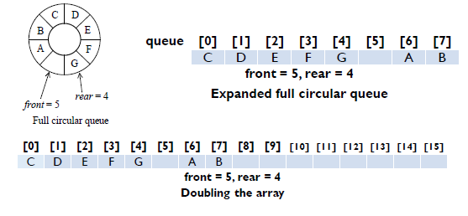

There are two possible solutions to this problem.

1. Scenario 1 : After shifting right segment

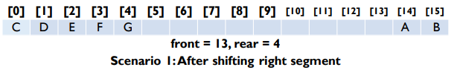

1. Scenario 2 : Alternative configuration

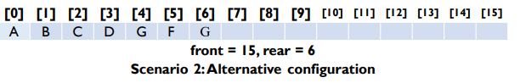

Please discuss and compare the pros and cons of the two scenarios.

1. According to the lecture video, when the capacity of a stack is insufficient to take new items, one needs to execute ChangeSize1D(stack, capacity, 2*capacity). Please write down the pseudocode of ChangeSize1D and give a brief description of your code.
2. Let bn be the number of different permutations obtainable by passing the numbers 1, 2, 3, …, n through a stack and doing push and pop all possible combinations.

(a) Give a recursive formula for bn.   
(b) Derive an analytical formula for bn

For example, assume that we have 1 2 3 three elements, then there are 5 possible push-pop combinations. Here we list three of them for your reference.

1) push1, push2, push3, pop3, pop2, pop1. So the order is 321

2) push1, pop1, push2, pop2, push3, pop3. So the order is 123

3) push1, push2, pop2, pop1, push3, pop3. So the order is 213

Please find the rule and answer the questions a and b.

1. Design a method that can implement a circular queue without wasting any memory space in queue? Please give a pseudocode.

B

A

D

C

1. Please design an algorithm to calculate Boolean Expression below:

(T|T)&F&(F|T)

Description: 1. “T” means True and “F” means False.  
 2. “!” means NOT , “&” means AND, and “|”means OR

3. The priority order of calculation is (>) > ! > & > |